

**PROJECT REPORT**

**CookBook:Your Virtual Kitchen Assistant**

YEAR : **2024 – 2025**

COLLEGE NAME: **K.C.S KASI NADAR COLLEGE OF ARTS & SCIENCE**

CODE : UNM203

DEPARTMENT : **COMPUTER SCIENCE**

PROGRAM : **B.C.A**

SEMESTER : **VI**

PROJECT SUBMITTED TO: UNIVERSITY OF MADRAS / NAAN MUDALVAN

Course Name : **Front End Development and Database Administration**

**TEAM LEADER: ABUBAKKARSIDDIQ.B**

**MEMBERS:**

1.LOGESH.K

2.IMTHIAS AHMED.M

3ABDUL RASSAQ.S

4.SANJAY KUMAR.M.S

**GUIDED BY: MRS.R.PADMADEVI**

**SPOC NAME: Dr.K. LALITHAKAMESWARI**

**CookBook**: Your Virtual Kitchen Assistant

**(React Application)**

# Introduction:

CookBook is a revolutionary web application designed to change the way you discover, organize, and create recipes. It caters to both novice and professional chefs, offering a user-friendly interface, robust features, and a vast collection of inspiring recipes.

# Description:

Welcome to the forefront of culinary exploration with CookBook!

Our cutting-edge web application is meticulously crafted to transcend the boundaries of culinary experiences, catering to the tastes of both passionate cooking enthusiasts, and seasoned professional chefs. With an emphasis on an intuitive user interface and a robust feature set, CookBook is poised to revolutionize the entire recipe discovery, organization, and creation process.

Designed with a commitment to user-friendly aesthetics, CookBook immerses users in an unparalleled culinary adventure. Navigate seamlessly through a vast expanse of culinary inspiration with features such as dynamic search effortlessly.

From those taking their first steps in the kitchen to seasoned professionals, CookBook embraces a diverse audience, nurturing a dynamic community united by a shared passion for the art of cooking. Our vision is to reshape how users interact with recipes, presenting a platform that not only sparks inspiration but also fosters collaboration and sharing within the vibrant culinary community.

Embark on this gastronomic journey with us, where innovation seamlessly intertwines with tradition. Every click within CookBook propels you closer to a realm of delicious possibilities. Join us and experience the evolution of recipe management, where each feature is meticulously crafted to offer a glimpse into the future of culinary exploration. Elevate your culinary endeavours with CookBook, where every recipe becomes an adventure waiting to be discovered and savoured.

# Scenario based introduction:

Sarah rummaged through the fridge, the fluorescent light casting an unappetizing glow on the wilting lettuce and forgotten container of yogurt. Dinnertime with her teenage son, Ethan, was fast approaching, and her usual creative spark was missing. "What are we even going to eat?" Ethan groaned from the doorway, his phone glued to his ear. Suddenly, a memory surfaced. Her friend, Maya, had been raving about a new recipe platform called CookBook. Intrigued by the promise of "elevating culinary endeavors" and "a realm

# Project structure:

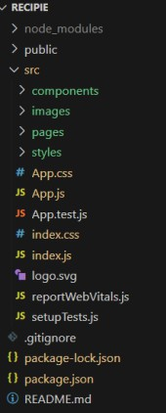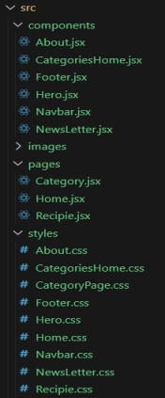

The hero component of the application provides a brief description about our application and a button to view more recipes.

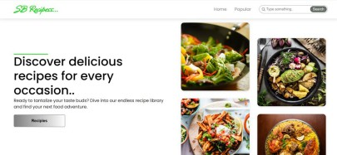

## Popular categories

This component contains all the popular categories of recipes..

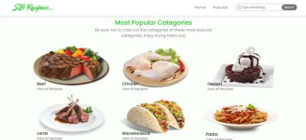

## Trending Dishes

This component contains some of the trending dishes in this application.

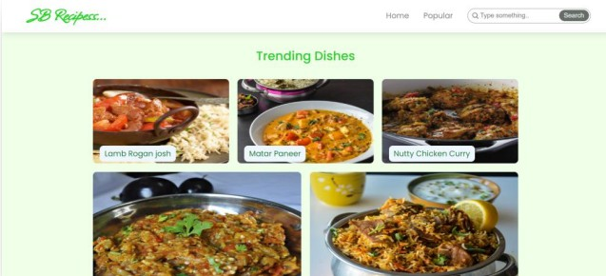

## News Letter

The news letter component provides an email input to subscribe for the recipe newsletters.

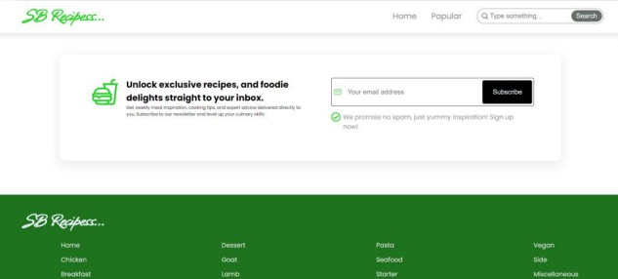

## Category dishes page

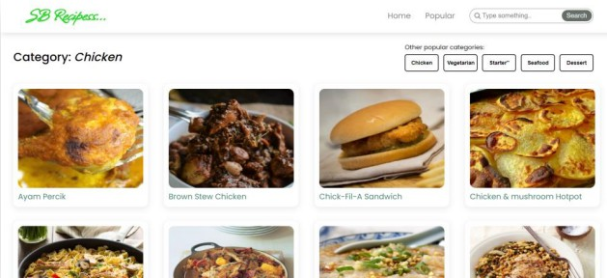The category page contains the list of dishes under a certain category.

## Recipe page

The images provided below shows the recipe page, that includes images, recipe instructions, ingredients and even a tutorial video.

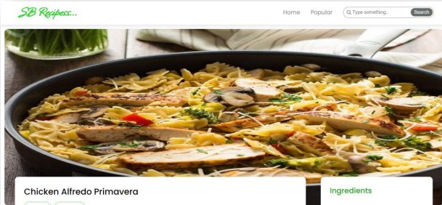

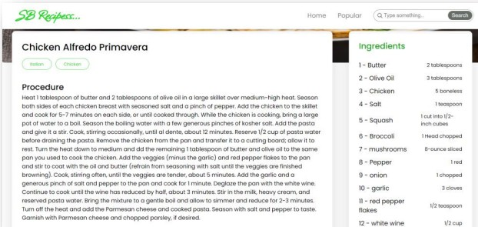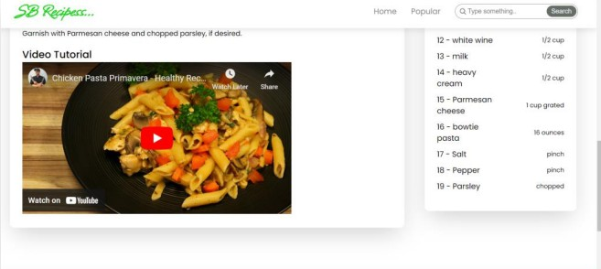

Project demo link:

[Cook video - Google Drive](https://drive.google.com/drive/folders/1JzB6AeoDcBYCMeGxriUXE2uR43zzu-V2)